SECTION FB

PISTONS, CONNECTING RODS, LARGE AND  
SMALL-END BEARINGS

CONTENTS

Removing Pistons and Connecting Rods .. Dismantling and Inspecting Pistons and Piston Rings Inspecting Connecting Rods and Bearings.. Assembling and Fitting Pistons and Connecting Rods Special Tools ..

Chapter

1

2

3

4

5

CHAPTER 1

REMOVING PISTONS AND CONNECTING RODS

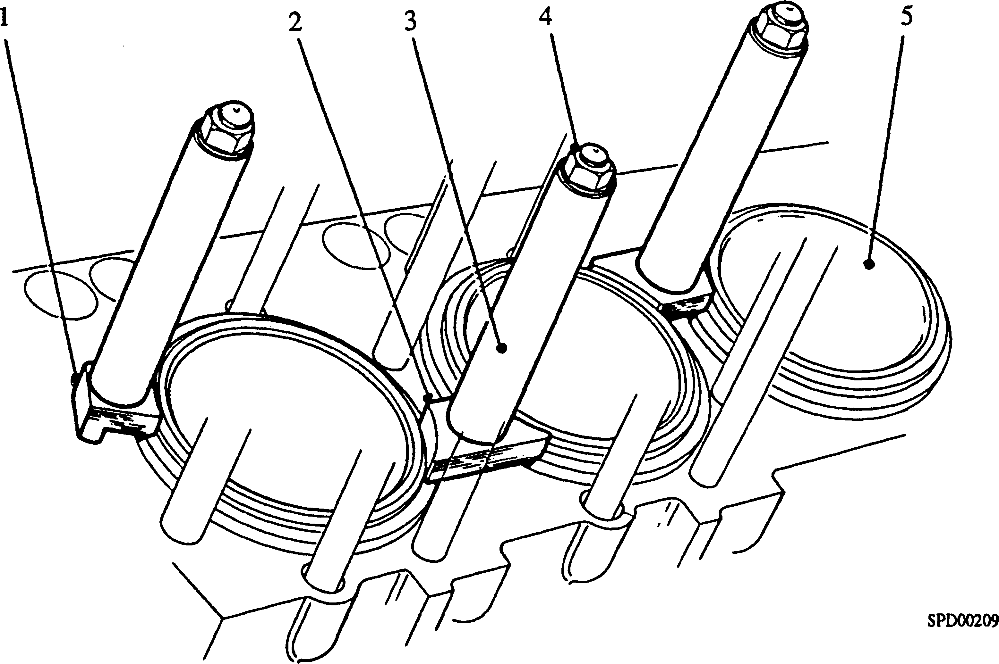

Key To Numbers

1. End clamp 4. Cylinder head nuts
2. Centre clamp 5. Cylinder liner
3. Distance piece

Fig FB.l Method of clamping cylinder liners

NOTE Removal and fitting of the pistons and connecting rods is a two man

operation

1. Figs FB.l, FB.2, FB.8, FB.10 and FB.ll illustrate the special tools required for removal and fitting of pistons and connecting rods. Due to component weight and the restricted working space available, both inside the crankcase and between the fuel pump camboxes and sub-frame or floor plates, removal and fitting MUST NOT BE ATTEMPTED without these tools.
2. The centre connecting rods are fitted to 'A' bank side of the engine and forked connecting rods to 'B' bank side. Looking at the free-end of the engine, 'A' bank is on the left hand side and 'B' bank on the right hand side.
3. Remove cylinder heads (Section FA). Fit end liner clamps (l)(Fig FB.l), centre liner clamps (2) and secure with distance pieces (3) and cylinder head nuts (4). This will eliminate the possibility of liner movement when barring the engine.
4. Remove carbon from the top of the liner to enable piston rings to slide smoothly out of the bore during removal sequence. Take care not to damage the chrome surface of the liner when removing carbon.
5. Remove crankcase doors from both sides of the engine and fit protector strip

(ll)(Fig FB.ll) to lower edge of crankcase aperture to prevent any damage that may be caused by the socket extension when releasing centre rod setbolts.

NOTE The square at the outer end of the centre rod bolt nuts locates between the webs of the rod and cap. THE BOLT ROTATES NOT THE NUT.

1. Fig FB.13 - Rotate crankshaft until centre connecting rod lower setbolt aligns with lower edge of 'A' bank crankcase aperture. Using socket spanner (13) together with drive extension release tension on bolt. DO NOT REMOVE BOLT. To avoid damaging bolt head, protector strip (12) should be used as a steady point.
2. Fig FB.14 - Rotate crankshaft until centre connecting rod upper setbolt aligns with lower edge of 'B' bank crankcase aperture. Using socket spanner and drive extension (13) as above, release and remove nut and bolt.
3. Fig FB.15 - Remove crankcase protector strip and fit supporting strap (11), securing strap to 'A' bank side of crankcase. Position crankpin approximately 25° from VTC towards 'B' bank. Hold centre connecting rod cap in position from 'B' bank side of engine and remove remaining centre rod setbolt and nut from 'A' bank side of engine. Lower connecting rod cap complete with half bearing shell on to support strap and withdraw through 'B' bank aperture altering support strap tension as required to facilitate removal. Remove support strap.
4. Fig FB.16 - Hold centre connecting rod complete with half bearing shell to large- end bearing block and rotate crankshaft to TDC 'A' bank position. Place pivot bracket (7) in position over the lower edge of crankcase aperture and secure with setscrews. Bolt centre connecting rod support (1) to lifting lever (4), place lever in pivot bracket slot locating it on the first notch and engage support with connecting rod. The 'ears' of the support engage with recesses in connecting rod, whilst 'hooked' portion engages over mating face serrations. Place lifting handle (5) over LOWER fork of lifting lever and insert securing pin. The outer end of the lifting lever is forked and two handles are provided to enable a full lift of piston and connecting rod assembly to be obtained within the confines of fuel pump cambox and engine sub-frame or floor plates.
5. Fig FB.17 - Taking the weight of piston and centre rod assembly on the lifting gear, bar crankshaft to TDC 'B' bank to disengage large-end bearing block from centre connecting rod. Remove half bearing shell from connecting rod. Lever connecting rod assembly up cylinder bore, sliding lifting lever forward to locate on the second notch to allow large-end of rod to pass up the bore, until lifting handle contacts sub-frame or floor plates. Maintaining load on lower lifting handle, fit second handle to upper fork, transfer retaining pin, take load and remove lower handle. Continue levering until piston gudgeon pin bore is sufficiently clear of top of liner to allow withdrawal gear (14) to be fitted. DO NOT allow weight of piston and connecting rod assembly to be supported by a piston ring as piston ring breakage may occur.
6. Support connecting rod assembly against top face of liner by means of withdrawal gear and remove lifting lever, support and pivot bracket. Withdraw piston and connecting rod from the engine. Collars are welded to handle of withdrawal gear to provide an anchor point for lifting tackle if required (see Fig FB.2).
7. Fig FB.18 - Rotate crankshaft to position large-end bearing block at 'A' bank aperture with serrated portion of lower large-end nuts, i.e., those on numbered side of rod, just clear of crankwebs. This position is important. If serrated portions of nuts are brought too far clear of crankwebs, spanner cannot be operated through crankcase door. Conversely, if serrated portions are not clear of crankwebs, partial spanner engagement will occur with subsequent damage to nuts. Place clamp band
8. around outer bearing surface of large-end block and tighten band by means of hand nut. Fit locking plates (10) to bolt heads on both sides of bearing block and using socket bar and socket (8) slacken nuts. Remove all nuts and locking plates.
9. Fig FB.19 - Rotate crankshaft to TDC 'B' bank and remove bolts upwards into cylinder bore. Bolts may be driven out with the aid of aluminium rod (6).
10. Fig FB.20 - Bolt forked connecting rod support (2), forked lever (3) and lifting lever (4) together, with support guide facing away from lifting lever. Ensure that protective pad is fitted to guide. Place pivot bracket (7) over lower edge of 'B' bank crankcase aperture and secure with setscrews. Place lifting lever in pivot bracket slot locating the first notch and engage support with connecting rod, allowing guide to contact liner bore. Operate lifting lever to separate connecting rod from bearing block dowels. Care must be taken during this operation as separation may be abrupt.
11. Fig FB.21 - Rotate crankshaft to position large-end bearing block at 'A' bank crankcase aperture, slide lifting lever forward to bring lift in line with cylinder bore; i.e. engage second notch and lever assembly up bore. Continue levering until gudgeon pin bore is sufficiently clear of top of liner to allow withdrawal gear (14) to be fitted. DO NOT allow weight of piston and connecting rod assembly to be supported by a piston ring as piston ring breakage may occur. Supporting connecting rod assembly against top face of liner by means of withdrawal gear, remove lifting lever assembly and pivot bracket. Withdraw piston and connecting rod from engine.
12. Fig FB.22 - Rotate crankshaft to bring large-end bearing block above lower edge of crankcase aperture and fit supporting strap (11), securing strap to 'A' bank side of crankcase. Tension strap and rotate crankshaft back until large-end block is resting on strap. Unscrew and remove clamp band hand nut, open band and lift off top half of bearing block and its half bearing shell. Adjusting tension of strap as required remove lower half bearing block complete with bearing shell and clamp band.

CHAPTER 2

DISMANTLING AND INSPECTING PISTONS AND PISTON RINGS

Dismantling

1. Remove piston rings. It is recommended that the special tool be used (see Chapter 5), as certain rings are made from a hard cast iron and cannot be removed using other methods.
2. Remove and discard gudgeon pin circlips. A small slot is machined in the piston for this purpose. Move circlip in groove until ends are near slot, place a thin probe under one end of the circlip and lever out.
3. Heat piston in oil to a temperature of 80 - 90°C and push out gudgeon pin using a wooden drift. DO NOT use hot water to heat piston due to danger of corrosion of ferrous parts.
4. Pistons and rings should be cleaned in kerosene or a non-caustic degreasing solution and all carbon removed. It is important that inside surfaces of piston crown are clean and that oil holes in oil control ring groove and gudgeon pin bosses are clean and unobstructed.

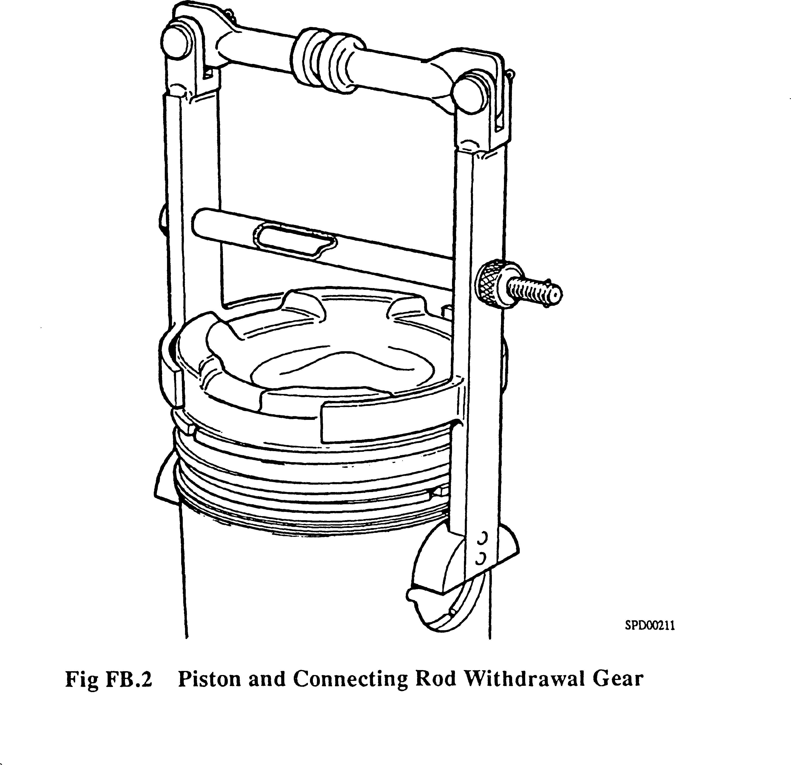

Inspection

1. All dimensions should be checked, where possible, against those given in the Schedule of Clearances and Wear Limits (Section CD).
2. Examine pistons for excessive scoring and scuffing. Check for cracks, particularly around points of sudden change of section, such as gudgeon pin bosses, ring grooves and lands, and the skirt. Check for indications of valves having struck the piston and that no signs of burning and corrosion are evident.
3. Measure bore of gudgeon pin bosses and ensure that circlip grooves are not damaged. Discard all circlips removed from pistons. Fit new circlips when pistons are assembled to rods.
4. Measure diameter of gudgeon pins and check for signs of excessive wear.
5. Check general condition of piston rings. Check ring gaps as follows:-
6. Ensure that all carbon has been removed from cylinder liner above upper limit of travel of top piston ring. This portion may be taken as representing the original bore size of liner. With ring placed squarely in this portion of liner, measure ring gap with feeler gauges. Check vertical clearance of piston rings in their grooves.

CHAPTER 3

INSPECTING CONNECTING RODS AND BEARINGS

1. The connecting rods and bearings should be thoroughly cleaned in kerosene or a non-caustic degreasing solution. Flush through the oilways in the connecting rods and large-end bearing blocks to ensure they are clear.

Centre Connecting Rod

1. Examine the general condition of the connecting rod and cap.
2. Examine the bearing surface of the small-end bush for scoring and measure the bore. Renew if necessary.

NOTE New small-end bushes should be frozen in a bath of liquid nitrogen.

This will reduce the outer diameter of the bush sufficiently to permit hand fitting and allow the shoulders of the bush to be aligned with the rod.

WARNING DO NOT USE LIQUID OXYGEN OR LIQUID AIR FOR FREEZING. MOST PARTS WILL HAVE TRACES OF LUBRICATING OIL OR PRESERVATIVE OIL REMAINING ON THEM. A MIXTURE OF OIL AND EITHER LIQUID OXYGEN OR LIQUID AIR IS LIABLE TO CAUSE AN EXPLOSION.

1. Examine the condition of the threads in the connecting rod and cap.
2. Examine the mating face serrations of both rod and cap for fretting and fracture.
3. Examine bearing surfaces of the shells for signs of scoring or flaking. The bearings are steel shells lined with copper-lead alloy and finally lead-tin plated. It will be observed, upon examination of the bearing surfaces, that the lead-tin plating will be partially or completely worn away dependant upon the number of hours the bearings have been in service. THIS IS NOT an indication that bearings are unserviceable or in any way faulty as the purpose of the plating is to obviate the necessity for long 'running in' periods.
4. The bearing shells are positioned in the connecting rod by locating lugs, formed on the outer surface of the shells, engaging with notches machined in the connecting rod bearing bore. Both shells are slotted for oil transfer, that for the rod half having the slot extending almost to the locating lug whilst the slot in the cap half is opposite to the locating lug. IT IS VERY IMPORTANT THAT THE SHELLS ARE CORRECTLY POSITIONED. To further assist in correct fitting, the half shells are etched 'R' or 'C' indicating that they should be fitted to the rod or cap respectively. These marks are on the edge of the shell facing the free-end of the engine.
5. To ensure correct assembly the rod and cap are etched with a number indicating the cylinder to which they must be fitted. These numbers should be adjacent. Refer to 'Connecting Rod Marking' at the end of this Chapter.

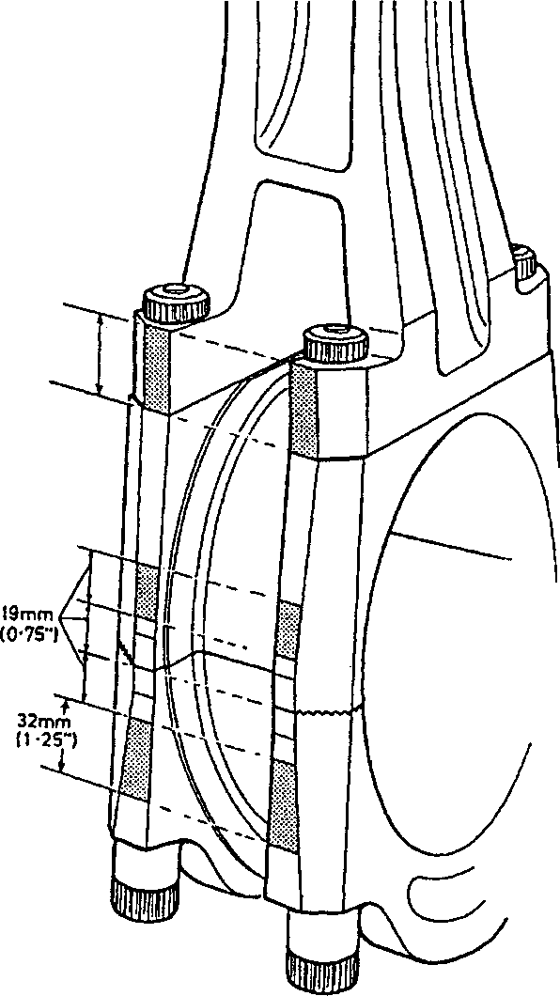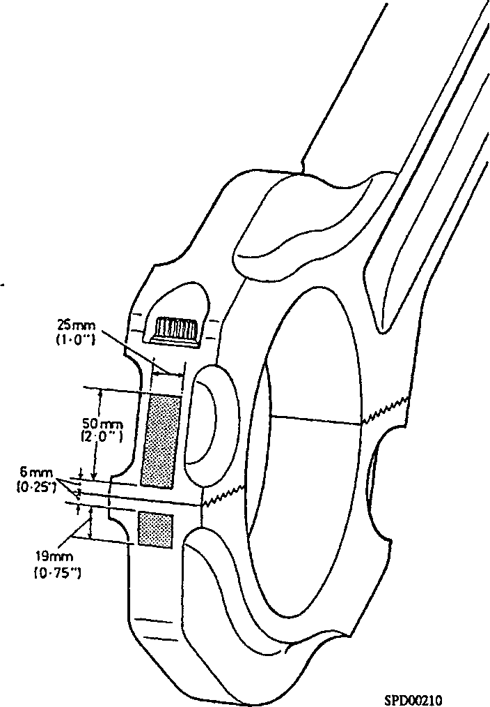Fig FB.4 Areas for marking connecting rod.

1. Examine the bore of the connecting rod and cap for fretting. This will be shown by small areas of metal transferred from the back of the bearing shell to the connecting rod or cap. These made be removed by using a grade 120 honing stone with paraffin or white spirit as a lubricant and finally finishing using a grade 280 honing stone. Special attention should be given to complete removal of all transferred metal to restore the seating to its original standard. The connecting rod and cap should be renewed if the fretting appears excessive. Thoroughly wash after stoning.

Checking Ovality and Bore (Fig. FB.5)

1. Assemble cap to rod, and using PBC as appropriate, fit and tighten bolts and nuts to the correct torque loading (see Section CE). DO NOT FIT BEARING SHELLS.

NOTE Should it be found necessary to hold assembly in a vice, then soft jaw

guards or soft packing pieces must be used.

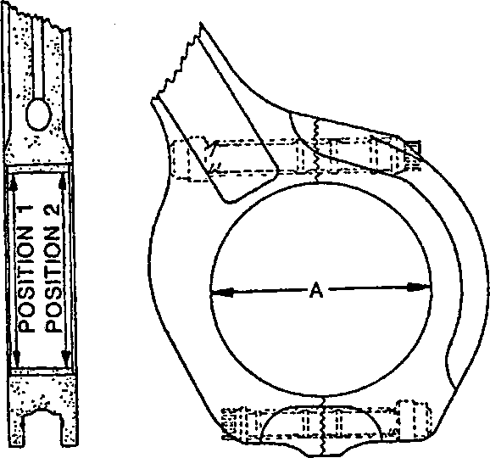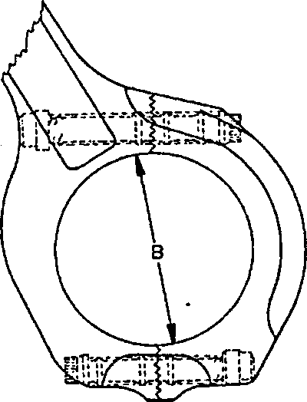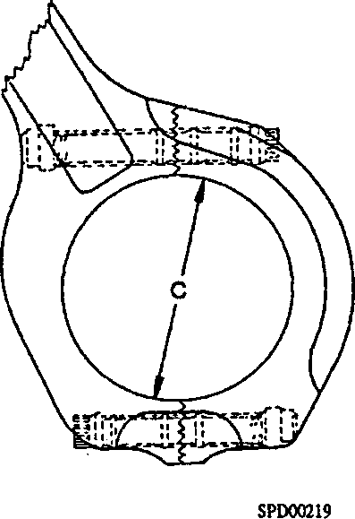Fig. FB.5 Centre Connecting Rod Measurement

1. Referring to Fig FB.5 and using a setting ring and bore gauge (Chapter 5), measure the diameter of the bore at 'A', 'B', and ’C\ 12.7 mm (0.5 in) in from both ends of the bore.
2. Record the measurements for reference purposes.
3. If any measurement is outside the above parameters the connecting rod assembly must be renewed.
4. Although the difference between the maximum and minimum dimensions is
5. 127 mm (0.005 in) the maximum allowable ovality is 0.076 mm (0.003 in) taken from either of the dimensions.

|  |  |  |
| --- | --- | --- |
| Position | Minimum  Dimension | Maximum  Dimension |
| A  At vertical axis of rod, ie., at 90° to ’split' | 184.125 mm (7.2490 in) |  |
| B and C  6.35 mm (0.25 in) above split on one side to same distance below split on opposite side |  | 184.163 mm (7.2505 in) |

TABLE I CENTRE CONNECTING ROD BORE Forked Connecting Rod

1. Examine the bearing surface of the small-end bush for scoring and measure the bore. Renew if necessary. Refer to centre connecting rod for fitting procedure.
2. Examine bearing surfaces of the shells for signs of scoring or flaking and the steel backing for fretting (see also Para 3.9). The bearings are steel shells lined with copper-lead alloy and finally lead-tin plated. It will be seen, on examination of the bearing surfaces, that the lead-tin plating will be partially or completely worn away dependant upon the number of hours the bearings have been in service. THIS IS NOT an indication that bearings are unserviceable or in any way faulty as the purpose of the plating is to obviate the necessity for long 'running in' periods. Bearings showing signs of fretting of the steel backing should be renewed.
3. The bearing shells are positioned in the large-end block by locating lugs, formed on the outer surface of the shells, engaging with notches machined in the bearing block bore. Both shells are slotted for oil- transfer, that for the rod half block having a short slot extending from joint face on locating lug side, while the cap half has a slot extending two thirds of the shell. IT IS VERY IMPORTANT THAT THE SHELLS ARE CORRECTLY POSITIONED. To further assist in correct fitting, the half shells are etched 'R' or 'C' and the station number indicating that they should be fitted to rod or cap on that station. These marks are on the outer face of the locating lugs.
4. To ensure correct assembly the connecting rod and bearing block halves are etched with a number indicating the cylinder to which they must be fitted. When assembled these numbers should be in line. Refer to Para 3.1 and FB.21.
5. Examine general condition of connecting rod and bearing block.
6. Examine the mating face serrations of both halves of bearing block for signs of damage. Renew bearing block if damage is sufficient to hold the halves apart. No attempt should be made to reclaim by stoning. Examine locating dowels for cracks. Renew if necessary.
7. Examine the bore of the bearing block for fretting. This will be shown by small areas of metal transferred from the back of the bearing shell to the connecting rod or cap. These made be removed by using a grade 120 honing stone with paraffin or white spirit as a lubricant and finally finishing using a grade 280 honing stone. Special attention should be given to complete removal of all transferred metal to restore the seating to its original standard. The bearing block should be renewed if the fretting appears excessive. Thoroughly wash after stoning.

Measuring Bearing Block Bore and Checking ovality (Fig FB.6)

1. Fit bearing block to connecting rod. Using PBC as appropriate, fit and tighten bolts and nuts to full stretch figure using stretch gauge as detailed in Chapter 4 of this section. DO NOT FIT BEARING SHELLS.

NOTE Should it be found necessary to hold assembly in a vice, then soft jaw

guards or soft packing pieces must be used.

1. Using a setting ring and bore gauge (Chapter 5), measure the block bore at A, B and C approximately 12.7 mm (0.5 in) in from both ends of the bore.

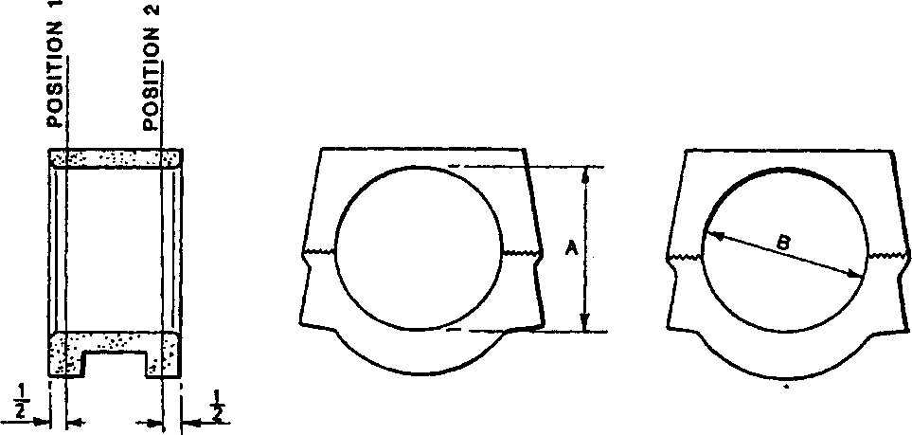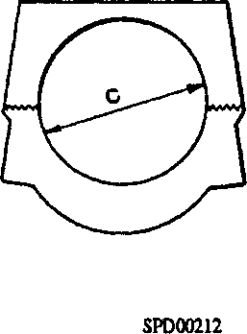Fig FB 6 Bearing Block Bore Measurement

1. Record the measurements for reference purposes.
2. If any measurement is outside the parameters in Table 2 the bearing block must be renewed.
3. Maximum allowable ovality as shown by the dimensions in Table 2 is 0.152 mm (0.006 in).

|  |  |  |
| --- | --- | --- |
| Position | Minimum  Dimension | Maximum  Dimension |
| A  At vertical axis of rod, ie., at 90° to ’split’ | 145.96 mm (5.7465 in) |  |
| B and C  6.35 mm (0.25 in) above split on one side to same distance below split on opposite side |  | 146.114 mm (5.7525 in) |

TABLE 2 BEARING BLOCK BORE

Measuring the outer Tracks. (Fig FB.7)

1. Remove bearing block from connecting rod, fit bearing shells and refit bearing block to connecting rod. Using PBC as appropriate, fit and tighten bolts and nuts to full stretch figure using stretch gauge as detailed in Chapter 4 of this section.

NOTE Should it be found necessary to hold assembly in a vice, then soft jaw guards or soft packing pieces must be used.

1. Using an External Micrometer, measure the outer track of the block.

NOTE Owing to the shape of the block it will be necessary to take these measurements approximately 25.4 mm (1 in) in from either end of the block.

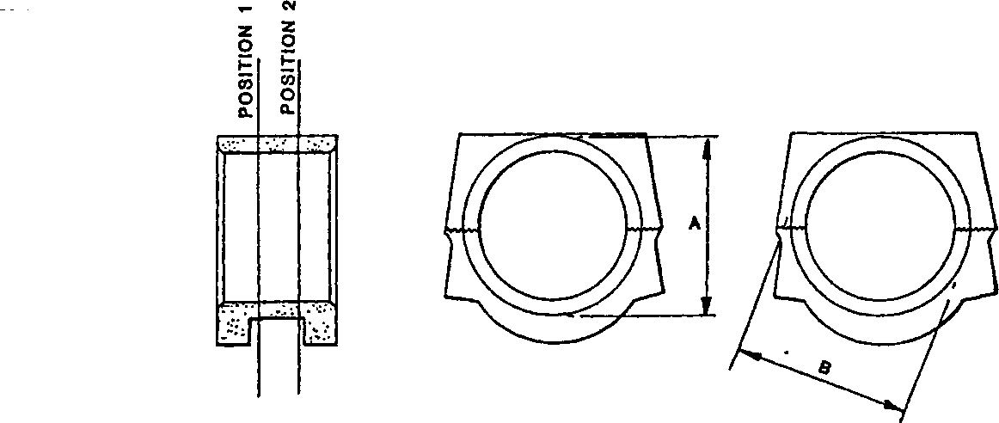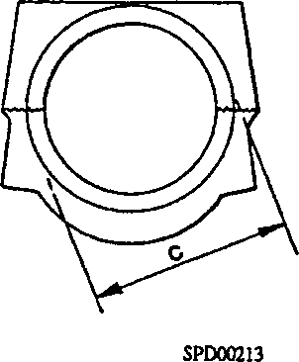Fig FB.7 outer Track Measurement

1. Record the measurements for reference purposes.
2. If any measurement is outside the parameters in Table 3 the bearing block must be renewed.
3. Maximum allowable ovality as shown by the dimensions in Table 2 is 0.152 mm (0.006 in).

Large-end Bolts

1. Examine threads of bolts and nuts for distortion and serviceability.
2. Examine measuring lands on bolt extremities for damage.
3. Examine bolt location and under head lands for damage and fretting.
4. Existing nuts must be free from damage on pressure faces, threads and serrations, if in doubt renew.

|  |  |  |
| --- | --- | --- |
| Position | Minimum  Dimension | Maximum  Dimension |
| A  At vertical axis of rod, ie., at 90° to 'split' | 177.71 mm (6.9965 in) |  |
| B and C  6.35 mm (0.25 in) above split on one side to same distance below split on opposite side |  | 177.86 mm (7.0025 in) |

TABLE 3 BEARING BLOCK OUTER TRACK

1. Check the free length of the forked rod bolts using stretch gauge (18)(Fig FB.2). Any bolt which does NOT meet gauge limits must be renewed.
2. Renew all bolts and nuts at Major Overhaul or after 24,000 hours running time, DO NOT ANNEAL.
3. Examine nuts for damage on pressure faces, threads and serrations. Renew if damaged.

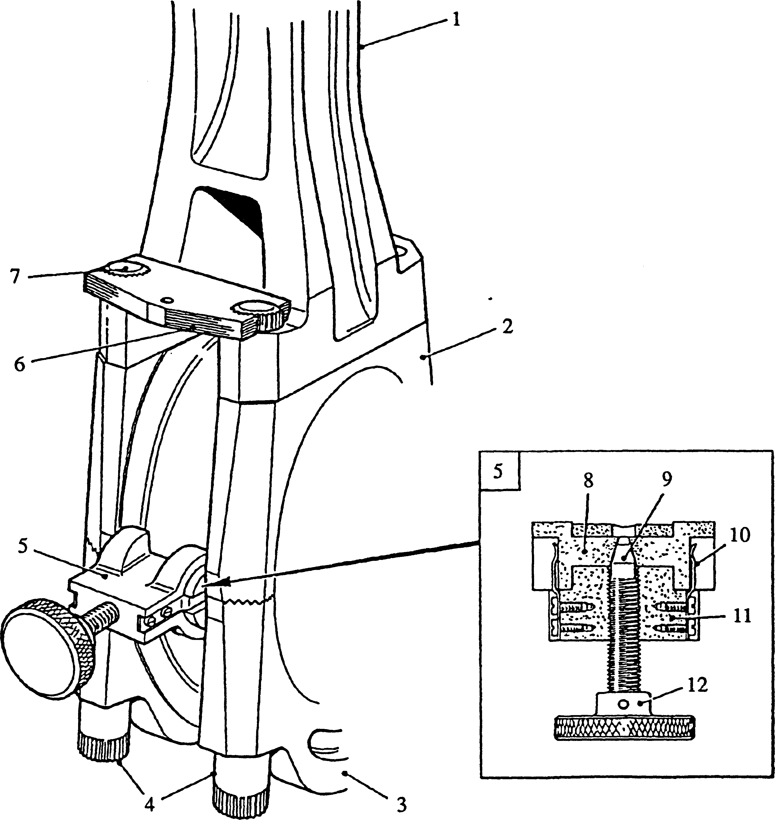

Key to numbers.

|  |  |  |  |
| --- | --- | --- | --- |
| 1. | Forked connecting rod | 7. | Large-end bolt |
| 2. | Large-end block,rod half | 8. | Anvil |
| 3. | Large-end block,cap half | 9. | Expanding screw |
| 4. | Large-end block nuts | 10. | Return spring |
| 5. | Centralising tool | 11. | Body |
| 6. | Locking plate | 12. | Handnut |

Fig FB.8 Alignment of large-end block and forked connecting rod

1. Renew all bolts and nuts after 24,000 hours running time, DO NOT ANNEAL.

CAUTION IN THE EVENT OF PISTON SEIZURE BEING EVIDENT AT ANYTIME, THE LARGE-END BOLTS MUST BE RENEWED.

CHAPTER 4

ASSEMBLING AND FITTING PISTONS AND CONNECTING RODS

NOTE All joints and ’O' rings must be fitted dry unless otherwise stated.

General Notes

1. Each piston is marked on the bottom edge of the skirt with a reference, eg., 0M3A, indicating location to connecting rod, the cylinder number and the bank to which it is fitted. If a new piston is fitted, it must be marked with the same reference as the one it is replacing.
2. If a new connecting rod assembly and/or bearing shells are being fitted, they must be identified in exactly the same way as items they are replacing, (see Connecting Rod Marking paras 3.31 to 3.32)
3. Using a proprietary cleaner such as TRICHLOROETHANE ('GENKLENE') or 'LOCTITE' SAFETY SOLVENT, the bearing shells, bearing blocks and connecting rods should be cleaned and allowed to dry naturally. If manual drying is required for any reason, use a CLEAN paper towel. After the shells have been fitted to the blocks or connecting rods, apply a thin film of CLEAN oil to the BEARING surface ONLY.

Assembly

1. Fit one circlip to piston ensuring that it is seated correctly in its groove. Use a new circlip.
2. Heat piston in oil, position connecting rod in piston ensuring that location letter 'O' and station number on piston are on the same side as the station number on the rod and insert gudgeon pin. Fit second circlip, ensuring that it is seated correctly in its groove.

NOTE The piston location letter and station number are towards the outside of the engine when fitted.

1. Fit piston rings to their grooves. It is recommended that the special tool be used (see Chapter 5), as certain rings are made from a hard cast iron and cannot be fitted using other methods. Details of the rings fitted and their position on the piston are as follows:-
2. 1st or top groove, rectangular section compression ring.
3. 2nd groove, taper faced internally stepped ring fitted with step uppermost.
4. 3rd groove, slotted oil control ring fitted with backing spring.

The piston may be identified by the Part No stamped on the rim of the piston crown and by the letters 'ON' stamped on the underside of the piston skirt.

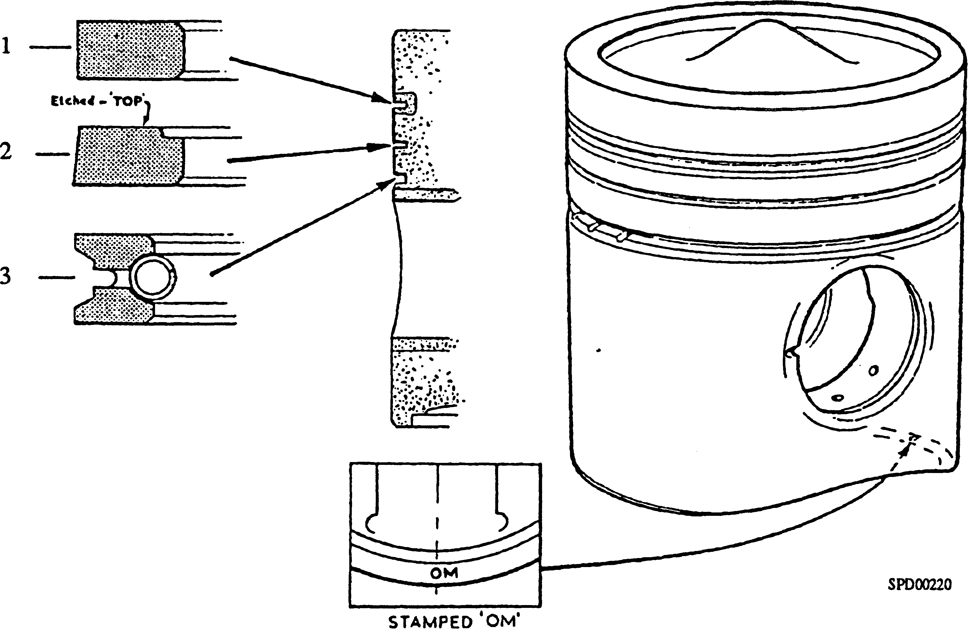

Fig FB.9 Piston and Ring Arrangement

Fitting

1. Fig FB22 - Fit support strap (11) securing it to 'A' bank side of crankcase. Rotate crankshaft to position crankpin just above strap on ’A’ bank side of engine. Clean bearing block halves and bearing shells (see para 4.3) and fit shells ensuring that locating lugs are engaged correctly. Smear bearing surface of lower half shell with oil and place open clamp band (9) and lower half bearing block on support strap with station number towards 'B' bank side of engine.
2. Slide half bearing block and clamp band along strap, locate to crankpin and support by means of strap. Oil crankpin and place top half bearing block and shell in position with station numbers in line. Ensure that locating dowel between block halves and mating face serrations are engaged correctly. Working from 'A' bank aperture, close clamp band and tighten using hand nut. Remove support strap.
3. Fig FB.21 - Thoroughly clean and oil cylinder bore, piston and rings. Space ring gaps equidistant around periphery of piston and fit piston band over rings. Fit withdrawal gear (14) to piston and, with connecting rod station numbers towards ’B' bank crankcase aperture, lower piston and connecting rod assembly into cylinder liner until it is supported against top face of liner by withdrawal gear. Place pivot bracket (7) over lower edge of 'B' bank crankcase aperture and secure with setscrews. Assemble forked connecting rod support (2), forked lever (3) and lifting lever (4), place lifting lever in pivot bracket slot, locating on second notch and engage support with rod. Fit lifting handle (5) to upper fork and fit securing pin. Take weight of assembly, remove withdrawal gear and lower assembly down bore until all the piston rings have entered liner. Remove piston band.

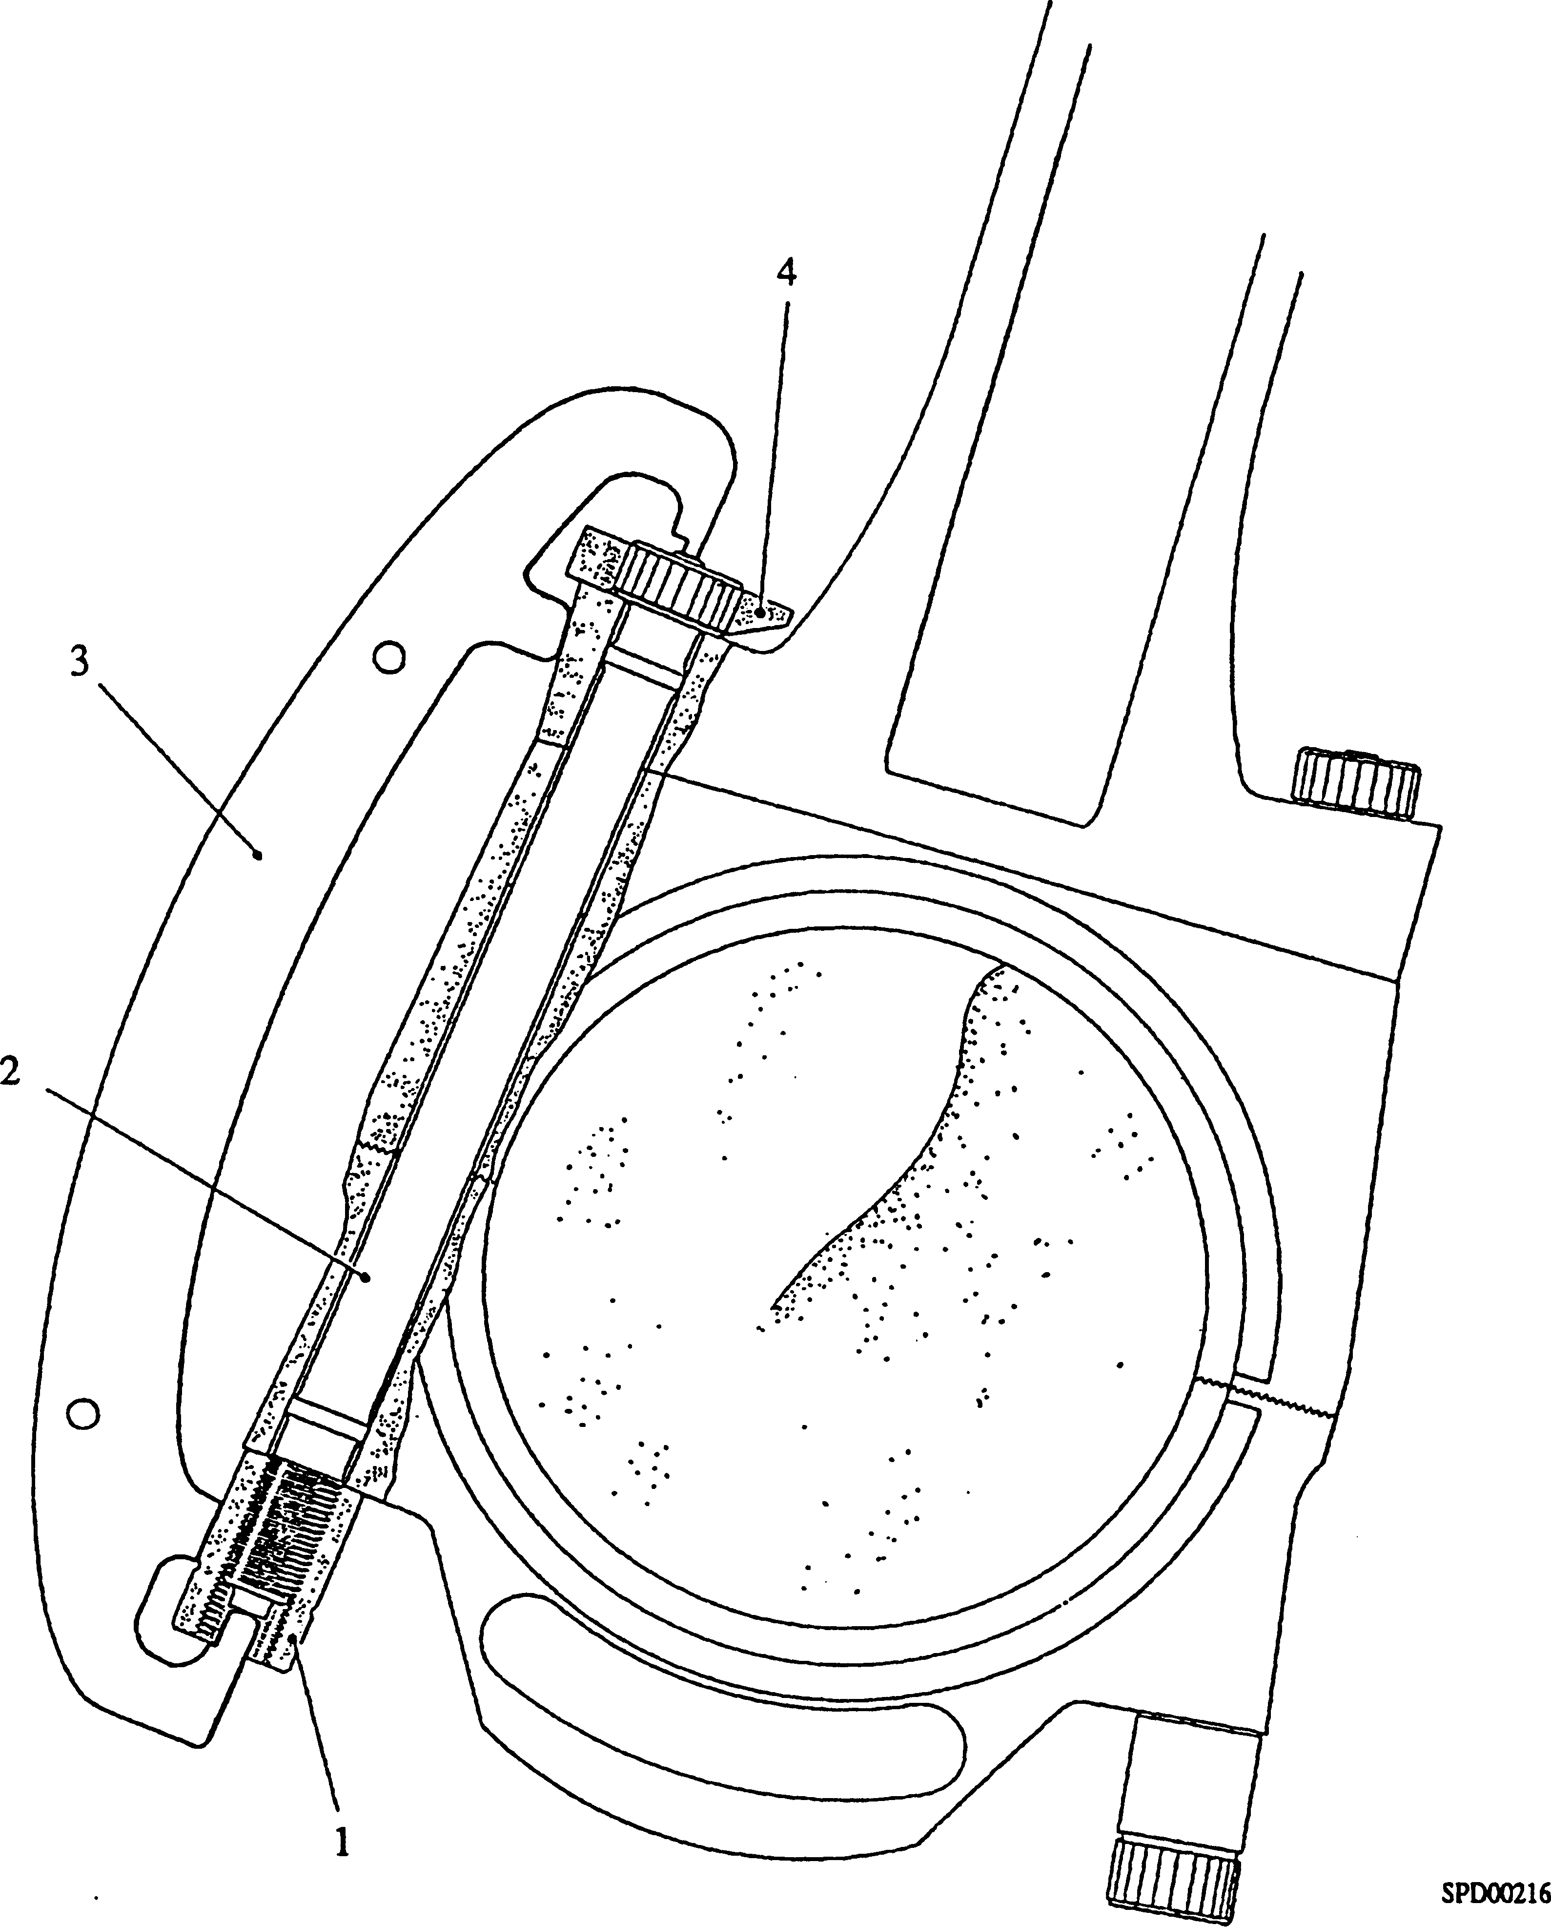

Key To Numbers

1. Nut for connecting rod 3. Stretch gauge
2. Bolt for connecting rod 4. Locking plate

Fig FB.10 Stretch gauge in use

1. Fig FB.20 - Change lifting handle to lower fork and draw lifting lever out of crankcase to engage first notch on pivot bracket to allow large-end block to be brought into position. Rotate crankshaft to bring large-end block to TDC position 'B' bank. Lower connecting rod on to large-end block ensuring that locating dowels engage correctly. Remove lifting gear and pivot bracket.

NOTE The locating dowels between connecting rod and large-end block must be towards 'B' bank side of engine.

1. Figs FB.19 and FB.8 - Retain crankshaft at TDC 'B' bank position. Pass large-end bolts up cylinder and insert through connecting rod and large-end block.
2. Figs FB.18 and FB.8 - Rotate crankshaft to position large-end block at 'A' bank crankcase aperture, fit nuts (4)(Fig FB.8) to large-end bolts and take up slack on all bolts. Remove clamp band from bearing block. Position crankshaft so that serrated portion of lower nuts are just clear of crank web. From 'B' bank side of crankcase, place centralising tool (5) between bearing block thrust facings at the point where the two halves joint and tighten knurled handnut (12) to force anvils (8) against thrust facings to correctly align halves.
3. Figs FB.18 and FB.8 - Fit locking plate (6)(Fig FB.8) to bolt heads and using socket bar (8)(Fig FB.18) with socket, tighten hut until stretch gauge (Fig FB.10) is a feel fit on bolt. Fit locking plate to inner bolts and tighten as above. Remove locking plate and centralising tool.
4. Figs FB.18 and FB.19 - Check end float of bearing block to crankshaft. This must be within limits quoted in Schedule of Clearances (Section CD).
5. Fig FB.17 - Rotate crankshaft to TDC 'B' bank. Clean and oil cylinder bore, centre blade rod, piston, and rings. Space ring gaps equidistant around piston and fit piston ring band. Fit withdrawal gear (14) to piston. Using withdrawal gear lower connecting rod and piston into cylinder bore until supported against top face of liner by withdrawal gear. The connecting rod large-end bore should face towards 'B' bank side of the engine. Place pivot bracket (7) over lower edge of 'A' bank crankcase aperture and secure with setscrews. Assemble centre connecting rod support (1) to lifting lever (4), place lifting lever in pivot bracket slot locating on the second notch and engage support with connecting rod. Fit lifting handle (5) to lifting lever UPPER fork, take weight of connecting rod assembly and remove withdrawal gear (14).
6. Fig FB.16 - Lower assembly down bore, engaging second lifting handle with lower fork, and withdrawing lifting lever (4) to engage first notch when necessary, until all piston rings have entered cylinder liner. Thoroughly clean rod half shell (see para 4.3) and fit to connecting rod ensuring that shell locating lug engages correctly with notch in connecting rod. Rotate crankshaft to TDC position ’A’ bank and engage connecting rod with bearing surface of large-end block. Remove lifting lever (4) and pivot bracket (7).
7. Fig FB.15 - Fit supporting strap (11) securing it to 'A' bank side of crankcase. Hold connecting rod to large-end bearing block and rotate crankshaft to position lower connecting rod bolt hole approximately in line with lower edge of crankcase aperture. Clean bearing bore of connecting rod cap and bearing shell (see para 4.3), fit shell to cap and smear bearing surface with oil.

NOTE The round portion of the special nut contacts the rod or cap and takes the load. The square portion locates between the rod or cap webs and prevents rotation. THE BOLT ROTATES NOT THE NUT

1. Apply anti-seize paste to threads of nuts and to threads and under the head of the bolts. Working from 'B' bank crankcase aperture and tensioning supporting strap as required, fit connecting rod cap. Hold nut in position on cap with square on nut facing away from cap, insert lower setbolt and screw up finger tight. Remove supporting strap.
2. Fig FB.14 - Fit protector strip (12) to lower edge of 'B' bank crankcase aperture, rotate crankshaft to position centre rod upper setbolt hole in line with lower edge of 'B' bank crankcase aperture. Hold nut in position on connecting rod with square on nut facing away from connecting rod, insert upper setbolt and using socket spanner, drive extension and torque wrench, tighten bolt to torque loading quoted in Section CE. Remove socket spanner and protector strip.
3. Fig FB.13 - Rotate crankshaft to position lower setbolt in line with lower edge of 'A' bank crankcase aperture, fit protector strip and using socket spanner, drive extension and torque wrench as in paragraph 4.18, tighten bolt to the same torque loading.
4. Check end float of centre connecting rod to bearing block. This must be within limits quoted in Schedule of Clearances (Section CD). As centre rod bearing cap is
5. 2 - 0.36mm (0.008 - 0.014in) narrower than connecting rod, end float measurement must be taken at connecting rod faces, NOT at cap faces.

CHAPTER 5

SPECIAL TOOLS

The following special tools are sufficient for carrying out all general maintenance, dismantling, overhaul and assembly operations on the pistons and connecting rods as detailed in this Section. Standard workshop tools such as ring spanners and sockets etc., are not listed.

|  |  |  |
| --- | --- | --- |
| DESCRIPTION | PART NO | USE |
| Torque Wrench, 300 - 750 lb.ft | OD17846 | To tighten centre rod bolts to a pre­determined loading |
| Socket Spanner, 24mm A/F | OD30718 | )  )To remove and tighten centre rod bolts |
| Extension, 3A in drive x 8in long | OD30147P04 | ) |
| Drive Converter lin to 3/» in drive | OD28466/01 | To provide drive conversion between torque wrench and drive extension |
| Socket Bar and 24 point serrated | Y3J70862B | )To remove and tighten forked |
| socket | YJ70586 | Connecting rod large-end nuts |
| Locking Plate | Y3J70638B | To lock forked rod bolts when removing or tightening nuts |
| End Liner Clamp | YJ70334BP3 | )  )To clamp cylinder liners to crankcase |
| Centre Liner Clamp | YJ70334BP4 | )after cylinder head removal, to prevent )liner movement when barring engine. |
| Distance Piece | Y3J70865 | ) |
| Protector Strip | Y3J70884 | To protect lower edge of crankcase aperture when removing or tightening centre rod bolts |
| Support Strap | Y3J70405 | To support weight of centre rod cap and bearing block halves during removal from crankcase |
| Bracket for Operating Lever | Y3J70839A | To provide a pivot point for lifting lever |
| Lifting Lever | Y3J70707B | To lever connecting rod assemblies up cylinder bore |
| Handle | Y3J70859 | Removable handles for lifting lever |
| Centre Rod Support | Y3J70842A | Engagement point between lifting lever and centre rod. |

|  |  |  |
| --- | --- | --- |
| DESCRIPTION | PART NO | USE |
| Forked Rod Support | Y3J70841A | Engagement point between lifting lever and forked connecting rod |
| Forked Lever | Y3J70837A | Extension between lifting lever and forked rod support to obtain required lift |
| Withdrawal Gear | Y3J70580 | To withdraw and replace piston and connecting rod assembly from cylinder bore |
| Clamp Band | Y3J70006A | To clamp large-end block halves together when connecting rod bolts are not fitted |
| Gauge for Large-end Bolts | Y3J70691A/2 | To check free length of large-end bolts |
| Stretch Gauge | Y3J70685B/3 | To check stretch of large-end bolts when tightened |
| Piston Ring Band | Y3J70602 | To clamp piston rings into their grooves for fitting into cylinder bore |
| Piston Ring Removal and  Fitting Tool | OD30583 | To expand piston rings prior to removal and fitting |
| Centralising Tool | Y3J70704 | To ensure correct lateral location between bearing block halves |
| Connecting Rod Bolt Removal Tool | Y3J70682A | Aluminium drift to assist in removal of forked connecting rod bolts from bearing block and rod |
| Bore Gauge | OD31678 | For measuring the bearing block bores |
| Setting Ring | OD31680 | For use with OD31678 |
| Bore Gauge | OD31679 | For measuring the blade rod bores |
| Setting Ring | OD31679 | For use with OD31679 |

Key To Numbers

1. Support, forked connecting rod
2. Lifting lever
3. Lifting lever handle
4. Support, centre connecting rod
5. Forked lever
6. Piston withdrawal gear
7. Socket bar, forked rod bolts
8. Locking plate
9. Clamp band narrow
10. Support strap
11. Protector strip
12. Connecting rod bolt removal tool
13. Pivot bracket
14. Centralising tool
15. Length gauge
16. Stretch gauge
17. Socket for forked rod nuts
18. Heavy duty socket
19. Clamp band wide

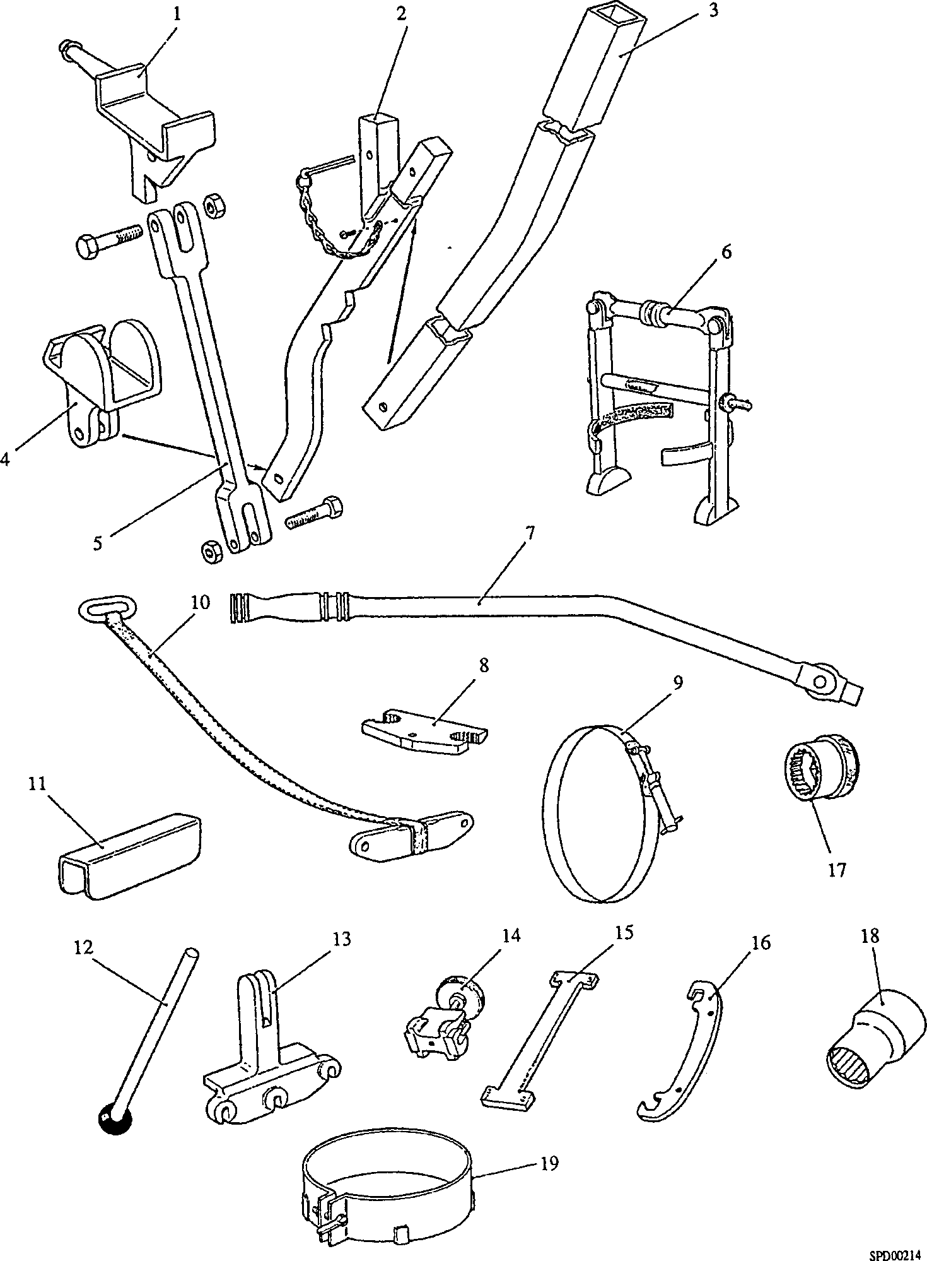

Fig FB.ll Piston and Connecting Rod Removal Tools

Key To Numbers

1. Piston
2. Circlip
3. Gudgeon pin
4. Small-end bush
5. Bolt for forked connecting rod and large-end block
6. Forked connecting rod
7. Oil groove
8. Dowel holes
9. Dowel, connecting rod to large-end block
10. Centre connecting rod bolt, long
11. Centre connecting rod cap
12. Nut for item 20
13. Cap half shell, centre rod
14. Rod half bearing shell
15. Cap half bearing shell
16. Large-end bearing block, rod half
17. Large-end bearing block, cap half
18. Nut for item 5
19. Rod half shell, centre rod
20. Centre rod bolt, short
21. Nut for item 10
22. Centre connecting rod

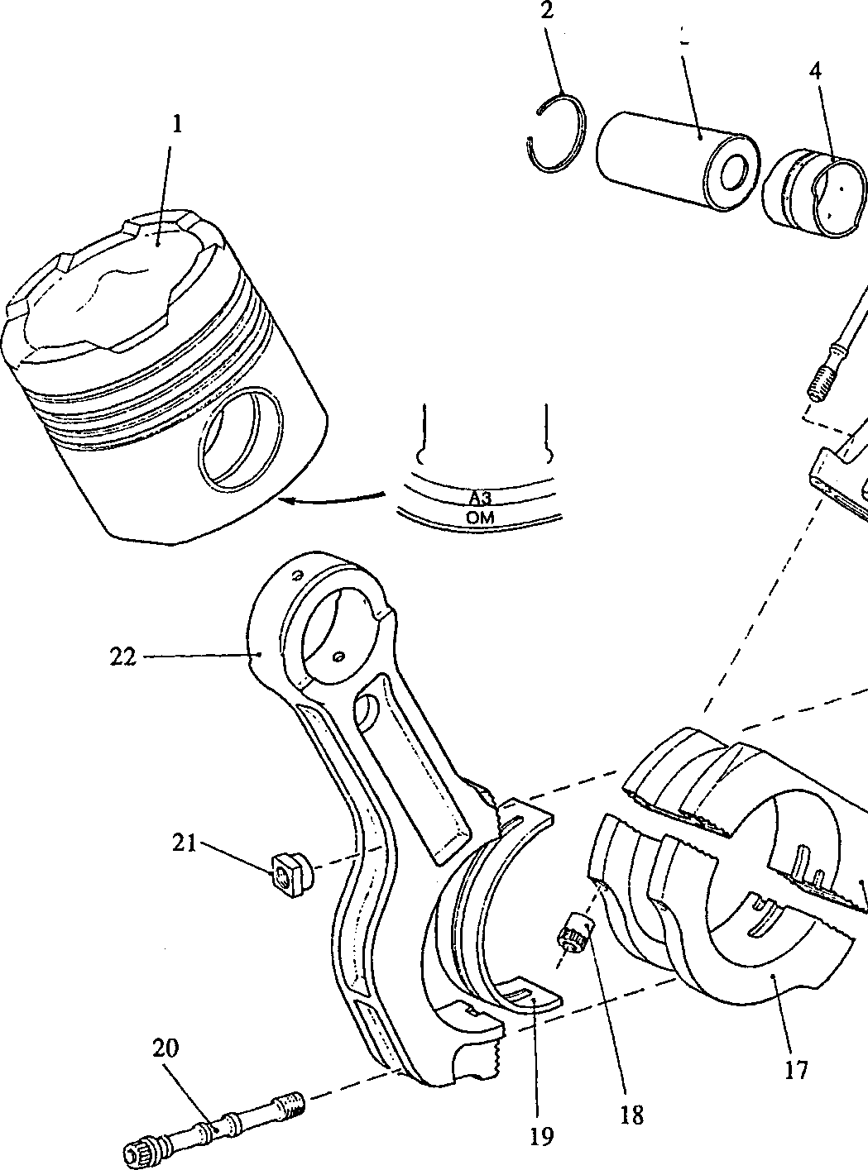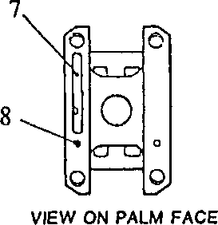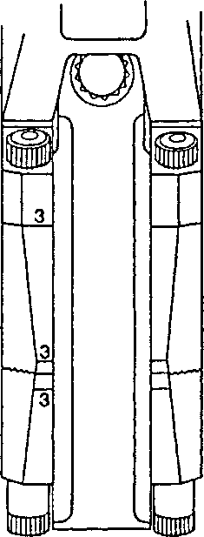

200FB019

3

10

VIEW THROUGH'B’ BANK  
CRANKCASE DOOR

Fig FB.12 Connecting rod assembly

S PD00217

|Ww/l

VIEW THROUGH ’A* BANK  
CRANKCASE DOOR

»o

(N

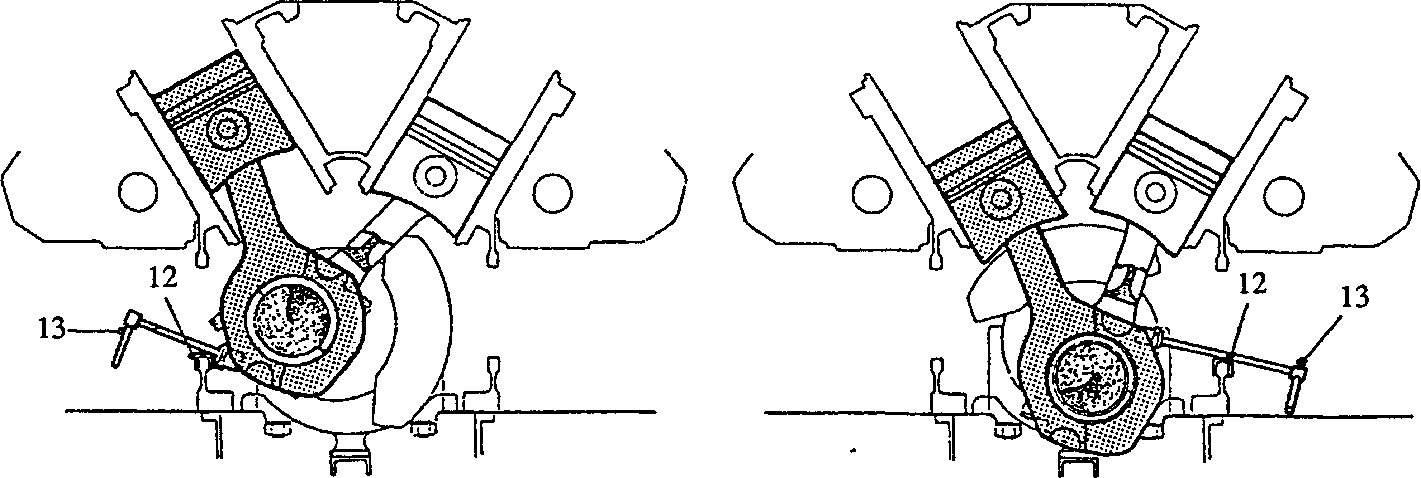

SPD00218A

Fig FB.13

Releasing lower setbolts, centre rod

Fig FB.14

Releasing upper bolt, centre rod

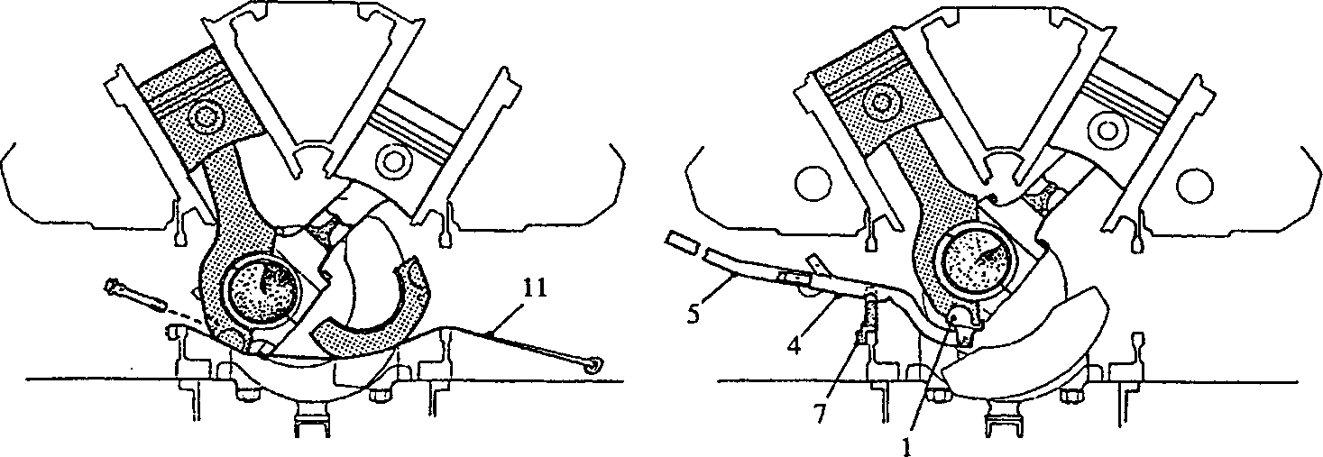

SPD00218/2

Fig FB.15

Removing centre rod bearing cap

Fig FB.16

Lifting gear fitted to centre rod

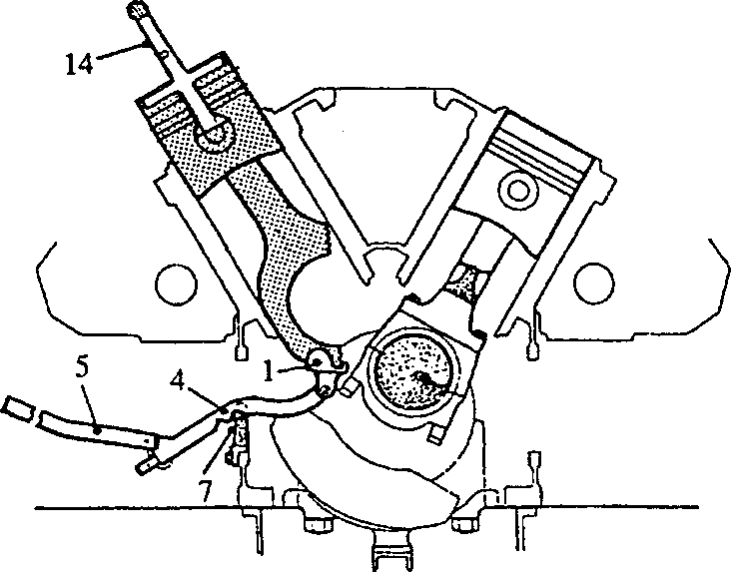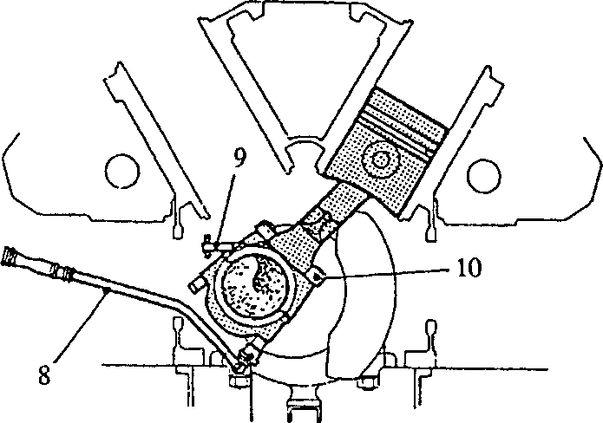

SPD00218/3

Fig FB.17

Fig FB.18

Releasing forked connecting rod bolts

Centre rod levered up bore,  
withdrawal gear fitted

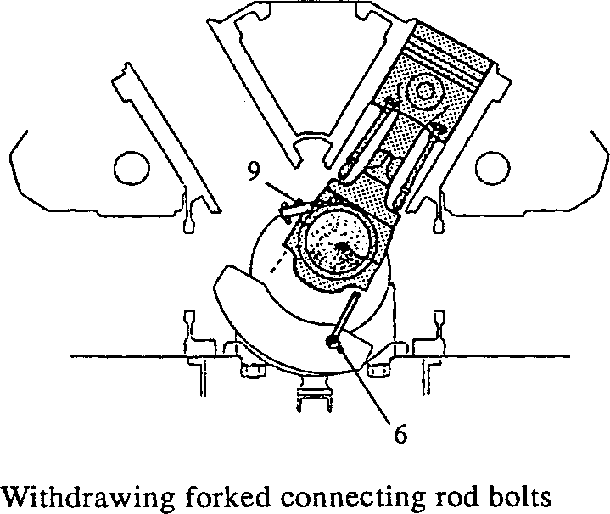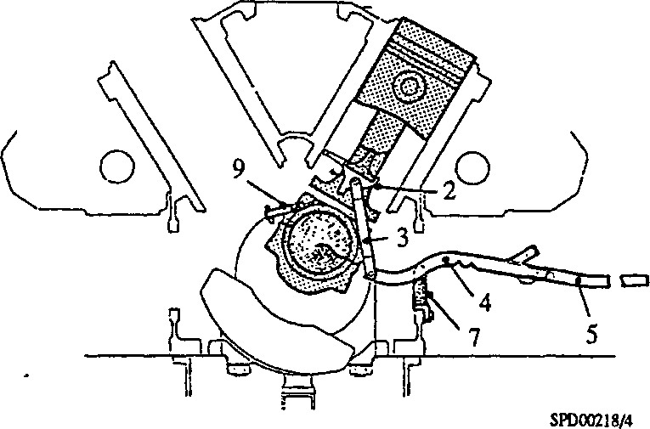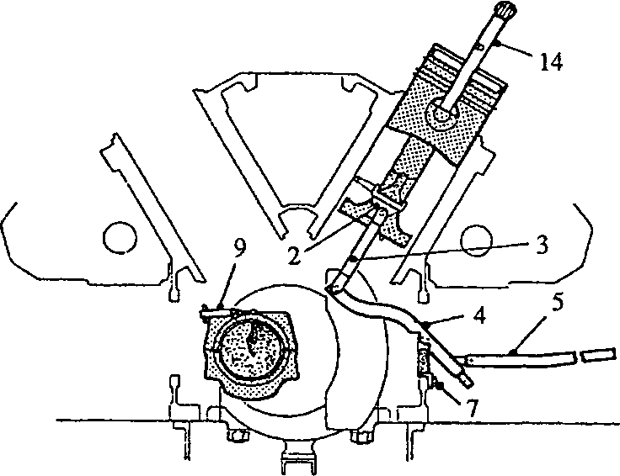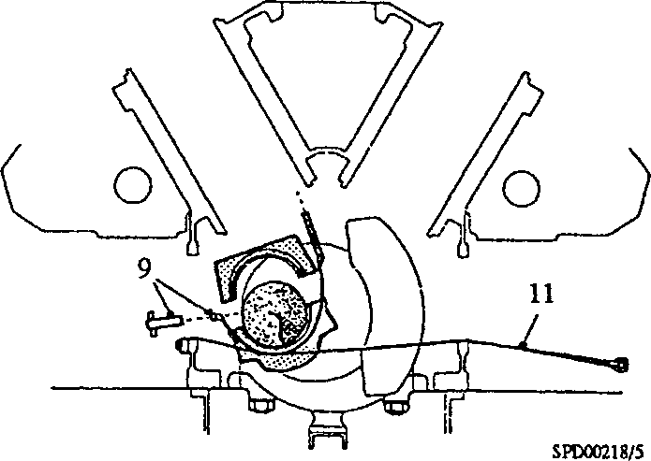

Fig FB.19 Fig FB.20 Lifting gear fitted to forked connecting rod

Fig FB.21

Forked connecting rod levered up bore,  
withdrawal gear fitted

Key to Numbers.

1. Centre connecting rod support
2. Forked connecting rod support
3. Forked lever
4. Lifting lever
5. Handle
6. Connecting rod bolt removal tool
7. Pivot bracket

Fig FB.22

Removing large-end bearing block

1. Socket bar and serrated socket for forked rod nuts
2. Clamp band
3. Locking plate
4. Support strap
5. Protector strip
6. M24 socket spanner, blade rod
7. Withdrawal gear

ADDENDUM

PISTONS AND RINGS

ADDENDUM 200FB009 PISTON AND RINGS.

PISTON PART NO Y3JX14011N.

The piston may be identified by the Part No stamped on the gudgeon pin boss, the letters 'ON' and the cylinder No. stamped on the underside of the piston skirt.

The ring arrangement is as follows (see Illustration below)

The letters 'ON' and the cylinder No. must face the outside of the engine.

1. 1st or top groove Part No Y3J14016G - rectangular section compression ring - V32 in wide
2. 2nd and 3rd grooves Part No Y3J14017E - taper faced internally stepped ring, fitted with step uppermost - V32 in wide
3. 4th groove Part No YJ14021A - slotted oil control ring fitted with backing spring - V4 in wide

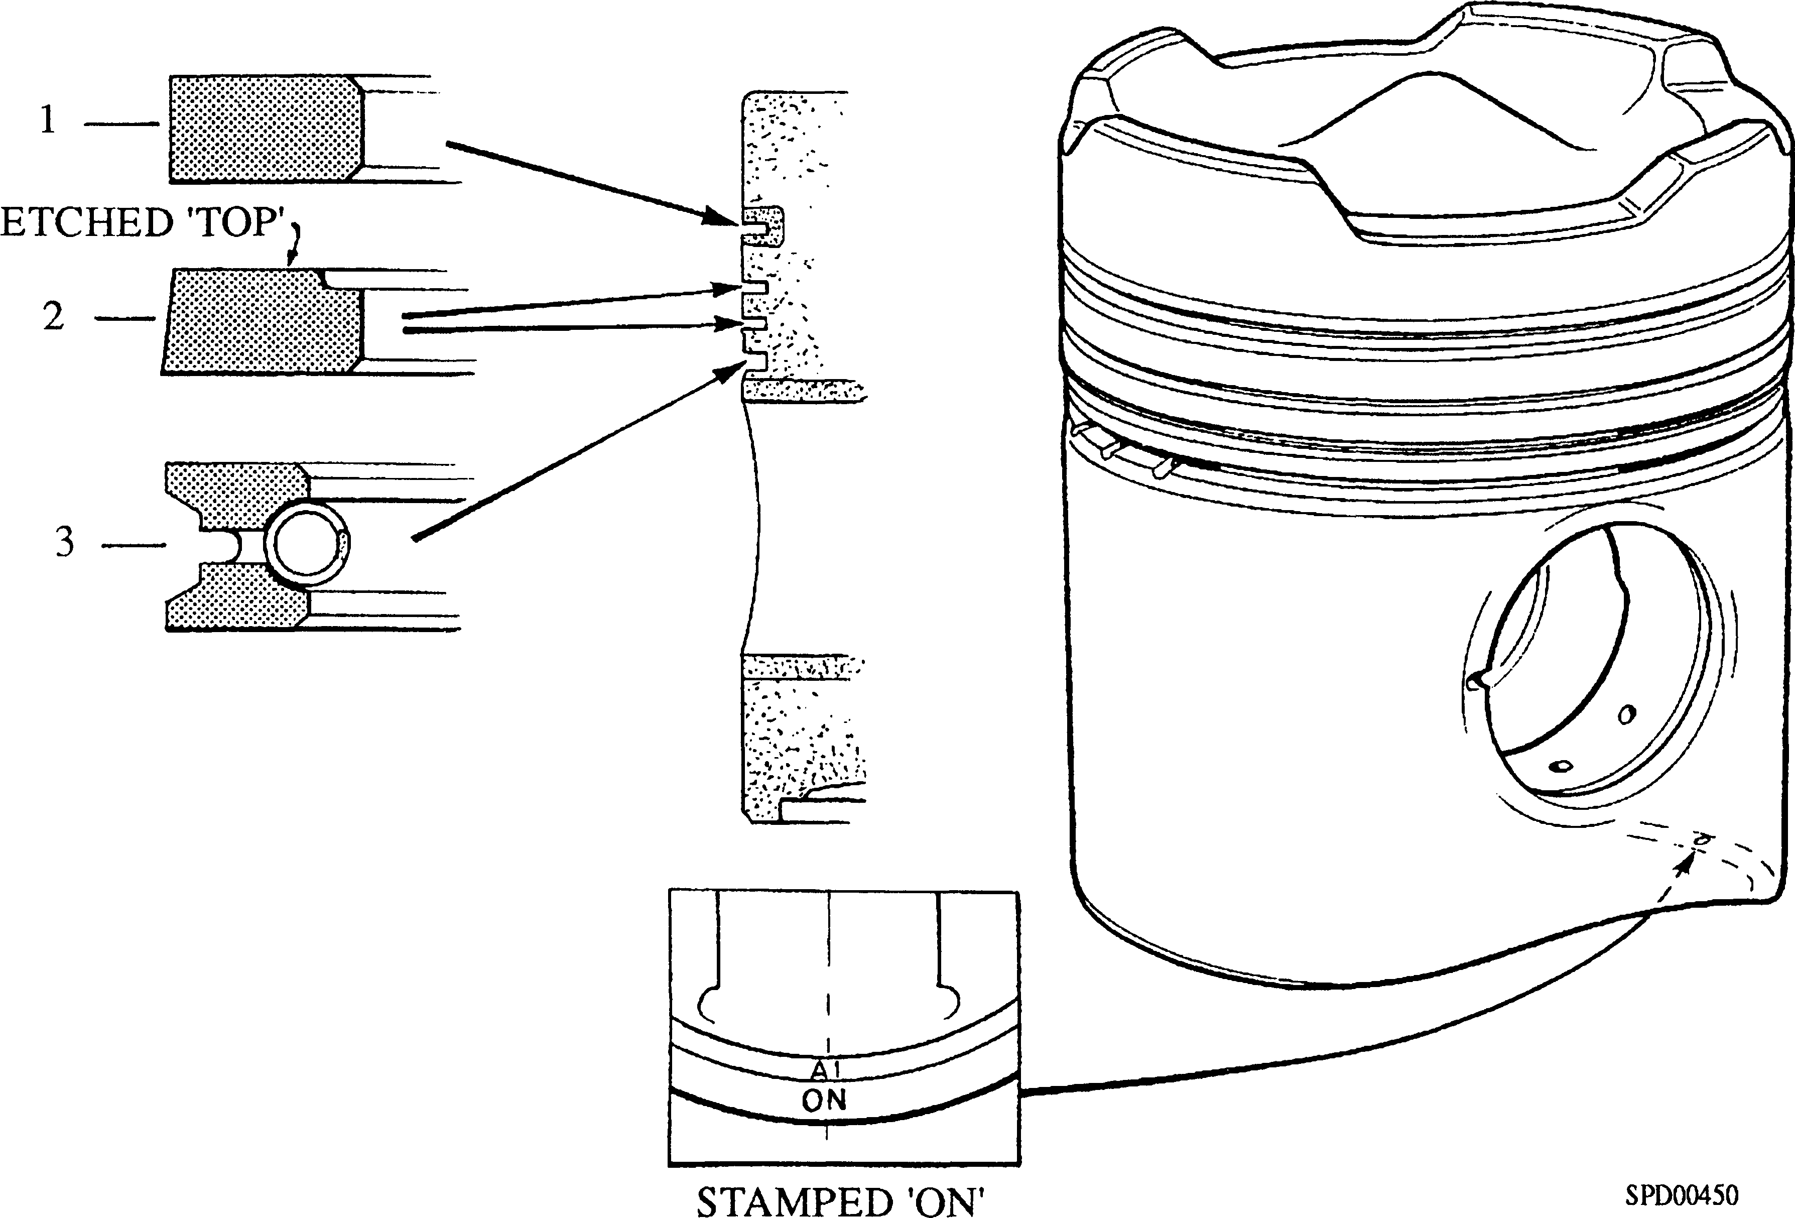

Fig 1 Piston and Ring Arrangement